**Documentation**

***IRIS-DATASET***

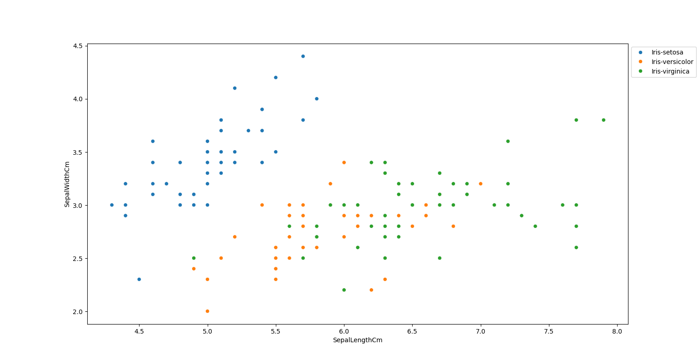**By using the Exploratory Data Analysis on Iris Dataset using python will gave some graphical data by analyzing the datas we conclude the points.**

* Species Setosa has smaller sepal lengths but larger sepal widths.
* Versicolor Species lies in the middle of the other two species in terms of sepal length and width
* 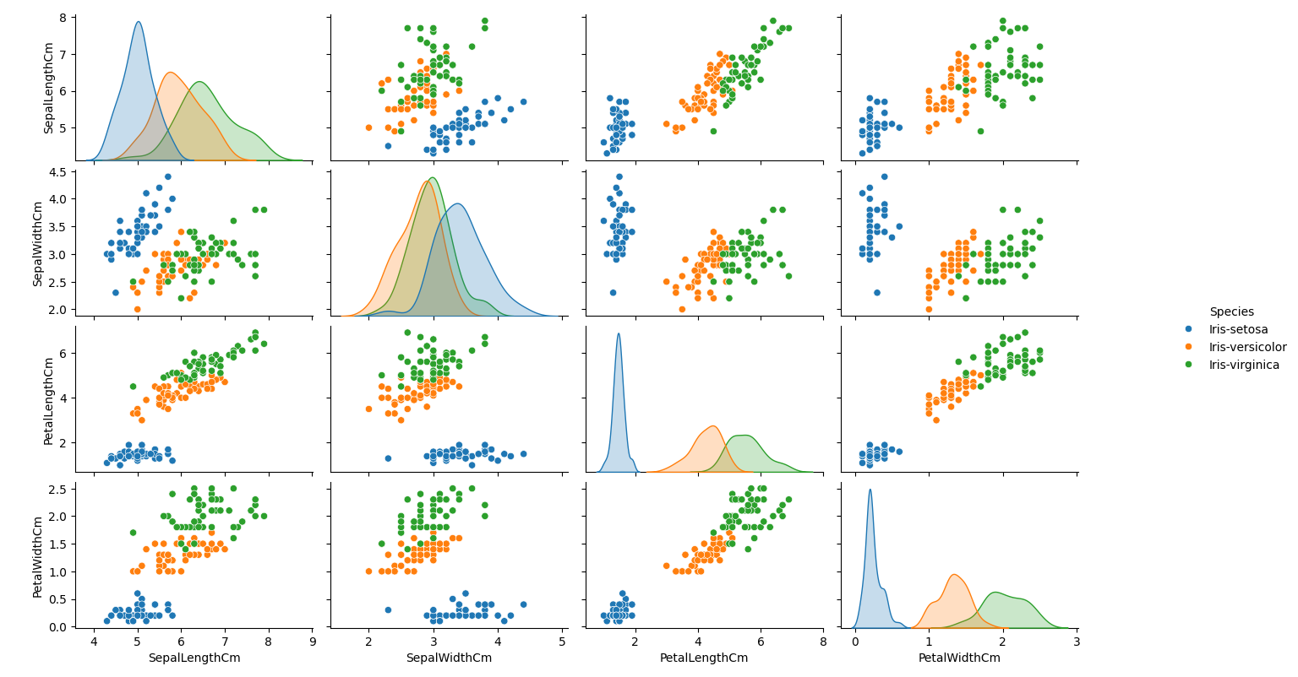Species Virginica has larger sepal lengths but smaller sepal widths.
* Setosa has the smallest of petals widths and lengths
* smallest sepal length but larger sepal widths

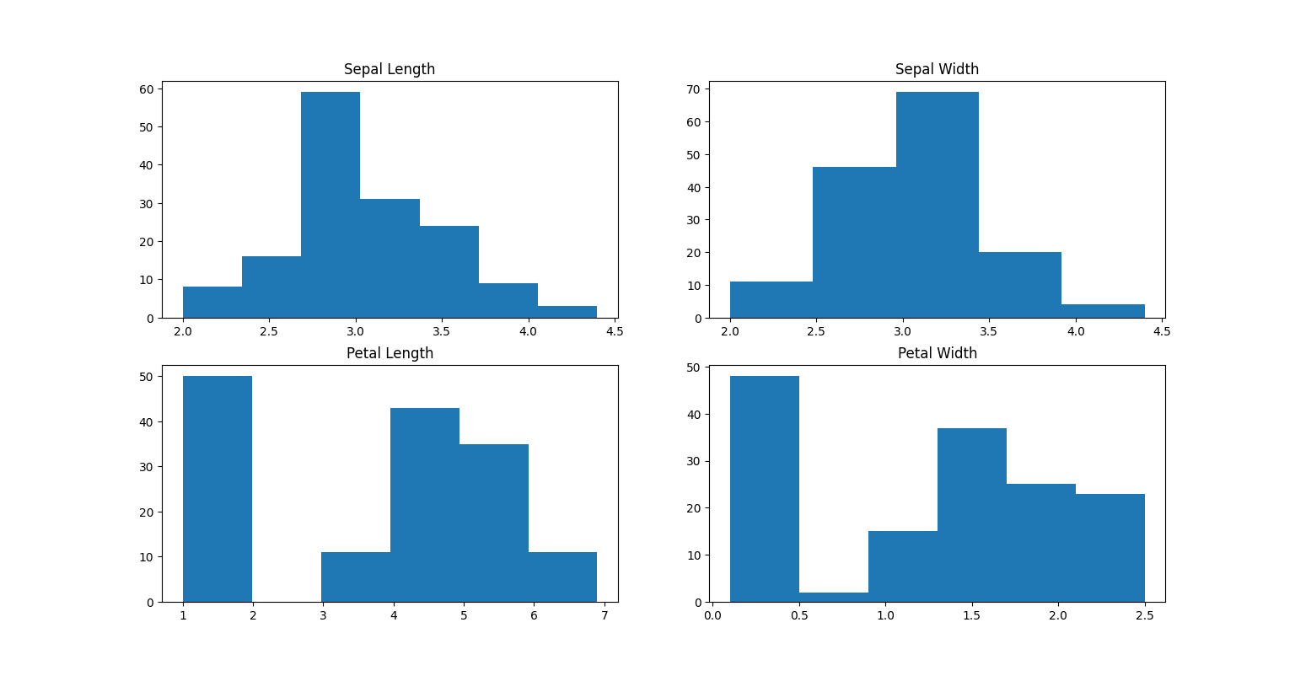***Histogram***

* *The highest frequency of the sepal length is between 30 and 35 which is between 5.5 and 6*
* *The highest frequency of the sepal Width is around 70 which is between 3.0 and 3.5*
* *The highest frequency of the petal length is around 50 which is between 1 and 2*
* *The highest frequency of the petal width is between 40 and 50 which is between 0.0 and 0.5*